**Name:Pruthviraj.R.Patil**

**Reg.no:16BCE1096**

**Topic name: Textile shop Database management system**

**Abstract:**

The textile shops database management system is the database management system where all the aspects related to the textile shop.

Here, in this model, the owners of the shop can extract the orders from the costumers and store it in the order list, according to the order list, the work gets distributed. Thus the employees of the shop get to prepare delivery list checking whether the items available or not, the order list is further divided as whether the customer issues the quality test. If yes, it is further related to Q analysis where different testers test the clothes. And finally after the delivery list is prepared, the employees deliver the orders to the respective customers.

Here all the info about the employees, the testers (password and usernames) , buyers are taken and properly related.

**E-R-Diagram of the database:**

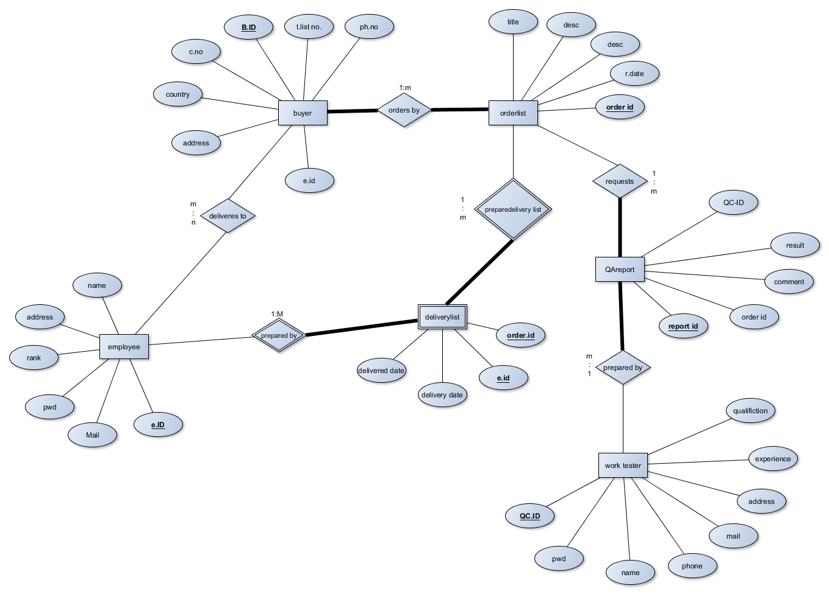

E.R.Relationship mapping:

